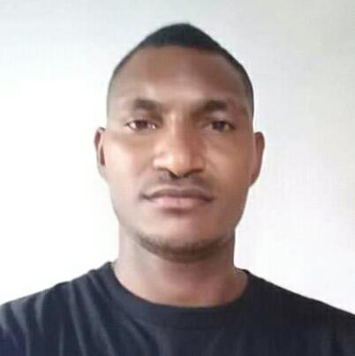Ceasar Dobi kabi

C/Mr Gwagura.

Hagara elementary school

Phone: 74738887

Gmail:ceasardobi@gmail.com

# Objective

To further develop my career in a professional and well established organisations as well as use my skills and knowledge to continually afford my personal and profession growth.

Further some of the objectives includes :

* To be productive and to increase the prosuctivi6of the organisation
* To be innovative, creative and quality in any given task
* To seek opportunities to learn more and to become more compete.

# Experience

CURRENTLY WORKING WITH:

THE SHADY REST HOTEL

Waitress or Weiter

Date start.17 April 2018

Duties: setting up for Dinner

Serve or do customer service and understand the menu or the task itself which makes me confidence to serve any level of customers regardless of any delay orders.

# Education

|  |  |  |
| --- | --- | --- |
| **Year** | School | Achievement |
|  |  |  |
| 2011 to 2012 | International Training Institute | Diploma in HRM |
| 2007 to 2008 | Kila Kila Secondary school | High school certificate |
| 1999 to 2006 | Sevese Morea Primary school | Primary school certificate |

# INTEREST

Watching Movies or news like reading books, do research, keen to learn new things and ask questions , believe in team work, computing and also spending time with my family.