Curriculum Vitae

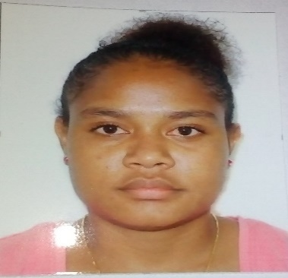

***Personal Details***

Full Name: Sharlyn Kulukulu

Date of Birth: 07th May 1995

Marital Status: Married (with two kids)

Home Province: Milne Bay

Religion: Catholic

Personal Mobile Number: 75274160 / 76001294

***Present Address:*** Sharlyn Kulukulu

C-/ Susan Nelson

Central Administration

P O Box 320, **University**

National Capital District

Port Moresby

Telephone: 3267317

Mobile Number: 73154111

***Education Qualification***

***Others***

Fire Safety Training - July 2019- Vision Citt Mall

Leadership Training - March 2021- Telikom Office

***Secondary Education***

2013 Grade 11 Juha College, didn’t complete the year

2011 - 2012 Grade 9 and 10 Caritas Technical Secondary School

***Primary Education***

2002 – 2009 Losuia Primary School

***Work Experience***

* Worked with Brian Bell Trade Electrical (Esco) as an Assistant Stock Inventory as well as doing Despatch duties and basic administration duties from October to December 2015
* Worked with Digicel PNG Ltd as a casual tele- caller for the Consumer Sale Department as well as doing sale for the department, doing customer service and basic administration duties from April 6th to July 2018.
* Worked with Rapid Fones at SVS 2 mile Digicel Flagship as a Sales Rep as well as doing cashier and customer service from July 19th to October 30th 2018.
* Currently working with Telikom Ltd as a Retail Sales Executive Team Leader, doing sales, customer service,cashier and general administration duties but not limited.

***Hobbies and Interest:***

Reading books and newspapers, sports, music, cooking and doing computer work, like online research, emailing, power point presentation, Microsoft word and Microsoft excel.

***Referees:***

Name: Iru Vegoa Rupa

Occupation: Retail Operations TL

Organization: Telikom Ltd

Contact Number: 76001755

Email: Iru.Vegoa-Rupa@telikom.com.pg

Name: Lois.Kave

Occupation: Retail Sales Supervisor

Organization: Telikom Ltd

Contact Number: 76001475

Email: Lois.Kave@telikom.com.pg

Name: Joseph Nana

Occupation: Sales Executive Team Leader

Organization: Digicel PNG Ltd

Contact Number: 73555525

Email: